DATA STRUCTURES (LAB)
LAB TASK 07 and 08



By
MISBAH KHALID
FA25-BCS-005

Submitted to,
Mr. BILAL BUKHARI
October 22, 2026

Department of Computer Sciences
COMSATS University Islamabad,
Attock Campus
LAB 07
TASK 01
CODE:
#include <iostream>
using namespace std;

// Structure for a tree node
struct Node {
int data; // Holds the node's value
Node* left; // Pointer to left child
Node* right; // Pointer to right child

// Constructor to initialize a new node
Node(int val) {
data = val; // Set the node's data
left = nullptr; // Initialize left child as null
right = nullptr;// Initialize right child as null
}
};

// 1. Pre Order Traversal (NRL - Node, Right, Left)
void preOrderNRL(Node* root) {
if (root == nullptr) return; // Base case: stop if current node is null
cout << root->data << " "; // Process Node first (N)
preOrderNRL(root->right); // Traverse Right subtree second (R)
preOrderNRL(root->left); // Traverse Left subtree last (L)
}

// 2. Post Order Traversal (RLN - Right, Left, Node)
void postOrderRLN(Node* root) {
if (root == nullptr) return; // Base case: stop if current node is null
postOrderRLN(root->right); // Traverse Right subtree first (R)
postOrderRLN(root->left); // Traverse Left subtree second (L)
cout << root->data << " "; // Process Node last (N)
}

// 3. In Order Traversal (RNL - Right, Node, Left)
void inOrderRNL(Node* root) {
if (root == nullptr) return; // Base case: stop if current node is null
inOrderRNL(root->right); // Traverse Right subtree first (R)
cout << root->data << " "; // Process Node second (N)
inOrderRNL(root->left); // Traverse Left subtree last (L)
}

int main() {
// Constructing a sample tree:
// 10
// / \
// 5 15
// / \ / \
// 3 7 12 20
Node* root = new Node(10);
root->left = new Node(5);
root->right = new Node(15);
root->left->left = new Node(3);
root->left->right = new Node(7);
root->right->left = new Node(12);
root->right->right = new Node(20);

cout << "Pre Order (NRL): ";
preOrderNRL(root); // Call NRL traversal
cout << endl;

cout << "Post Order (RLN): ";
postOrderRLN(root); // Call RLN traversal
cout << endl;

cout << "In Order (RNL): ";
inOrderRNL(root); // Call RNL traversal
cout << endl;

return 0;
}
OUTPUT:
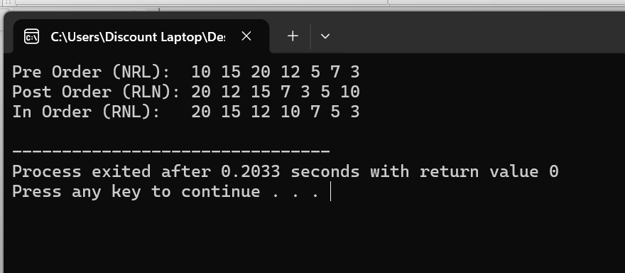
TASK 02
CODE:
#include <iostream>
using namespace std;

// Structure for a tree node
struct Node {
int data; // Holds the node's value
Node* left; // Pointer to left child
Node* right; // Pointer to right child

// Constructor to initialize a new node
Node(int val) {
data = val; // Set the node's data
left = nullptr; // Initialize left child as null
right = nullptr;// Initialize right child as null
}
};

// Function to print and count leaf nodes
int printAndCountLeaves(Node* root) {
// Base case: if the tree is empty, there are 0 leaves
if (root == nullptr) {
return 0;
}

// Check if the current node is a leaf node
// (It has no left child AND no right child)
if (root->left == nullptr && root->right == nullptr) {
cout << root->data << " "; // Print the leaf node's data
return 1; // Return 1 to add to the total count
}

// If it's not a leaf, recursively check both left and right subtrees
// and add their counts together
int leftLeaves = printAndCountLeaves(root->left); // Count leaves in left subtree
int rightLeaves = printAndCountLeaves(root->right); // Count leaves in right subtree

return leftLeaves + rightLeaves; // Return the total count for this branch
}

int main() {
// Constructing a sample Binary Search Tree:
// 10
// / \
// 5 15
// / \ / \
// 3 7 12 20
Node* root = new Node(10);
root->left = new Node(5);
root->right = new Node(15);
root->left->left = new Node(3);
root->left->right = new Node(7);
root->right->left = new Node(12);
root->right->right = new Node(20);

cout << "Leaf Nodes are: ";
int totalLeaves = printAndCountLeaves(root); // Call the function

cout << "\nTotal Leaf Nodes: " << totalLeaves << endl; // Print final count

return 0;
}
OUTPUT:
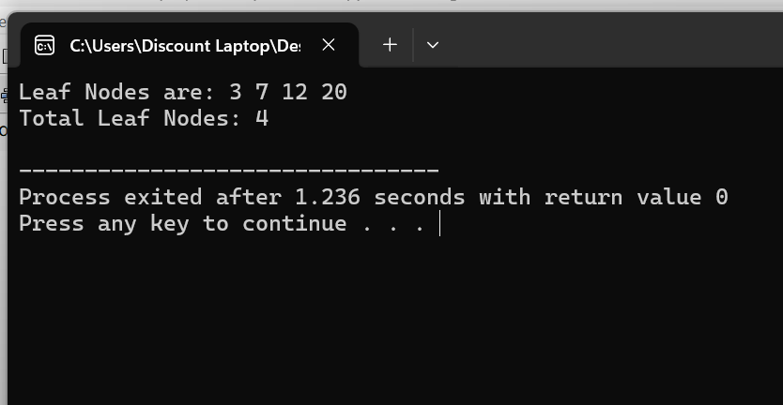

TASK 03
CODE
#include <iostream>
using namespace std;

// Structure for a tree node
struct Node {
int data; // Holds the node's value
Node* left; // Pointer to left child
Node* right; // Pointer to right child

// Constructor to initialize a new node
Node(int val) {
data = val; // Set the node's data
left = nullptr; // Initialize left child as null
right = nullptr;// Initialize right child as null
}
};

// Helper function to find the node with the minimum value in a tree
// Used in Case 3 (Node with two children) to find the Inorder Successor
Node* findMin(Node* root) {
while (root->left != nullptr) { // Keep traversing left until we can't anymore
root = root->left; // Move pointer to the left child
}
return root; // Return the leftmost (smallest) node
}

// Function to delete a node from the BST
Node* deleteNode(Node* root, int key) {
// Base case: if the tree is empty, return null
if (root == nullptr) {
return root;
}

// Step 1: Search for the node to delete
if (key < root->data) {
// Key is smaller, go to left subtree
root->left = deleteNode(root->left, key);
}
else if (key > root->data) {
// Key is larger, go to right subtree
root->right = deleteNode(root->right, key);
}
else {
// Step 2: Node found! Handle the 3 possibilities for deletion:

// Possibility 1 & 2: Node with NO children (leaf) OR node with ONE child
if (root->left == nullptr) {
Node* temp = root->right; // Store right child (or null if leaf)
delete root; // Delete the current node
return temp; // Return right child to replace current node
}
else if (root->right == nullptr) {
Node* temp = root->left; // Store left child
delete root; // Delete the current node
return temp; // Return left child to replace current node
}

// Possibility 3: Node with TWO children
// Find the Inorder Successor (smallest node in the right subtree)
Node* temp = findMin(root->right);

// Copy the successor's data to the current node
root->data = temp->data;

// Delete the successor node from the right subtree
root->right = deleteNode(root->right, temp->data);
}
return root; // Return the modified tree root
}

// Helper function to print tree in standard Inorder (Left, Node, Right) to verify deletions
void printInOrder(Node* root) {
if (root == nullptr) return;
printInOrder(root->left);
cout << root->data << " ";
printInOrder(root->right);
}

int main() {
// Constructing a sample BST:
// 50
// / \
// 30 70
// / \ / \
// 20 40 60 80
Node* root = new Node(50);
root->left = new Node(30);
root->right = new Node(70);
root->left->left = new Node(20);
root->left->right = new Node(40);
root->right->left = new Node(60);
root->right->right = new Node(80);

cout << "Original Tree (In-Order): ";
printInOrder(root);
cout << endl << endl;

// --- TEST CASE 1: Delete a Leaf Node (no children) ---
cout << "Deleting 20 (Leaf node)..." << endl;
root = deleteNode(root, 20);
cout << "Tree after deleting 20: ";
printInOrder(root);
cout << endl << endl;

// --- TEST CASE 2: Delete a Node with One Child ---
// (Let's delete 30, it now only has a right child 40)
cout << "Deleting 30 (Node with one child)..." << endl;
root = deleteNode(root, 30);
cout << "Tree after deleting 30: ";
printInOrder(root);
cout << endl << endl;

// --- TEST CASE 3: Delete a Node with Two Children ---
// (Deleting 50, the root, which has two children)
cout << "Deleting 50 (Node with two children)..." << endl;
root = deleteNode(root, 50);
cout << "Tree after deleting 50: ";
printInOrder(root);
cout << endl << endl;

return 0;
}

OUTPUT:
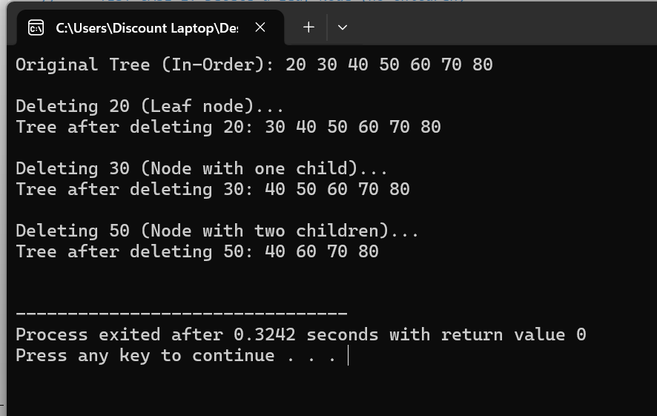

LAB 08:
TASK 01
CODE
#include <iostream>
#include <algorithm> // Required for the max() function
using namespace std;

// Structure for an AVL Tree Node
struct Node {
int data; // Stores the data value
Node* left; // Pointer to the left child
Node* right; // Pointer to the right child
int height; // Stores the height of the node

// Constructor to initialize a new node
Node(int val) {
data = val; // Set the data
left = nullptr; // Initialize left child as null
right = nullptr;// Initialize right child as null
height = 1; // A new node is initially at height 1
}
};

// Utility function to get the height of a node
int getHeight(Node* node) {
if (node == nullptr) return 0; // If node is null, height is 0
return node->height; // Otherwise, return the stored height
}

// Utility function to calculate the Balance Factor
// Balance Factor = height(left subtree) - height(right subtree)
int getBalance(Node* node) {
if (node == nullptr) return 0; // If node is null, balance is 0
return getHeight(node->left) - getHeight(node->right); // Calculate and return balance
}

// --- ROTATION 1: Right Rotation (LL Case) ---
Node* rotateRight(Node* y) {
Node* x = y->left; // x is the left child of y
Node* T2 = x->right; // T2 is the right child of x (which will move)

// Perform rotation
x->right = y; // x becomes the new root, y becomes its right child
y->left = T2; // T2 becomes the left child of y

// Update heights (must update y first, as it is now lower)
y->height = max(getHeight(y->left), getHeight(y->right)) + 1;
x->height = max(getHeight(x->left), getHeight(x->right)) + 1;

return x; // Return the new root (x)
}

// --- ROTATION 2: Left Rotation (RR Case) ---
Node* rotateLeft(Node* x) {
Node* y = x->right; // y is the right child of x
Node* T2 = y->left; // T2 is the left child of y (which will move)

// Perform rotation
y->left = x; // y becomes the new root, x becomes its left child
x->right = T2; // T2 becomes the right child of x

// Update heights (must update x first, as it is now lower)
x->height = max(getHeight(x->left), getHeight(x->right)) + 1;
y->height = max(getHeight(y->left), getHeight(y->right)) + 1;

return y; // Return the new root (y)
}

// Function to insert a node and automatically apply necessary rotations
Node* insert(Node* node, int key) {
// 1. Perform standard BST insertion
if (node == nullptr) return new Node(key); // Create new node if empty

if (key < node->data) {
node->left = insert(node->left, key); // Insert in left subtree
} else if (key > node->data) {
node->right = insert(node->right, key);// Insert in right subtree
} else {
return node; // Duplicate keys not allowed, return unchanged
}

// 2. Update height of this ancestor node
node->height = 1 + max(getHeight(node->left), getHeight(node->right));

// 3. Get the balance factor to check if this node became unbalanced
int balance = getBalance(node);

// 4. If unbalanced, apply rotations (4 Cases)

// Case 1: Left Left (LL) -> Apply Right Rotation
if (balance > 1 && key < node->left->data) {
return rotateRight(node);
}

// Case 2: Right Right (RR) -> Apply Left Rotation
if (balance < -1 && key > node->right->data) {
return rotateLeft(node);
}

// Case 3: Left Right (LR) -> Apply Left on child, then Right on node
if (balance > 1 && key > node->left->data) {
node->left = rotateLeft(node->left); // First, rotate left on left child
return rotateRight(node); // Then, rotate right on current node
}

// Case 4: Right Left (RL) -> Apply Right on child, then Left on node
if (balance < -1 && key < node->right->data) {
node->right = rotateRight(node->right); // First, rotate right on right child
return rotateLeft(node); // Then, rotate left on current node
}

return node; // Return the (potentially new) root of this subtree
}

// Helper function to print the tree in Pre-order (Root, Left, Right)
void printPreOrder(Node* root) {
if (root == nullptr) return; // Base case
cout << root->data << " "; // Print node
printPreOrder(root->left); // Go left
printPreOrder(root->right); // Go right
}

int main() {
Node* root = nullptr; // Initialize empty tree

// Inserting nodes. The AVL insert function will automatically
// figure out which rotations to apply to keep the tree balanced.
root = insert(root, 10);
root = insert(root, 20);
root = insert(root, 30); // Triggers RR Rotation (Left Rotation)

root = insert(root, 40);
root = insert(root, 50);

root = insert(root, 25); // Triggers RL Rotation (Right-Left Rotation)

cout << "Pre-order traversal of constructed AVL tree:\n";
printPreOrder(root);
cout << endl;

return 0;
}

OUTPUT:
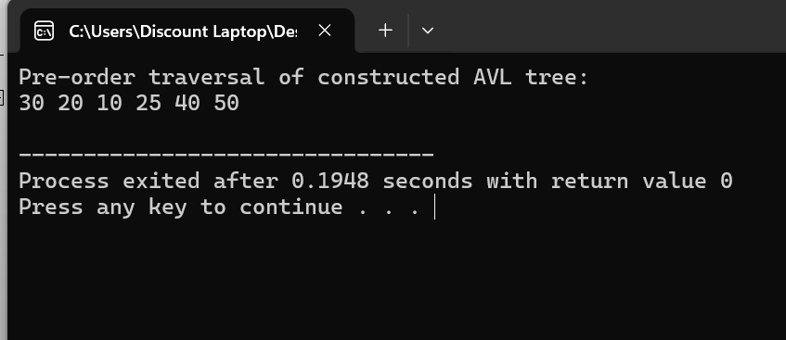

TASK 02
CODE:
#include <iostream>
#include <queue> // Required for level order traversal
using namespace std;

// Structure for a Tree Node
struct Node {
int data; // Stores the data value
Node* left; // Pointer to left child
Node* right; // Pointer to right child

// Constructor to initialize a new node
Node(int val) {
data = val; // Set data
left = nullptr; // Set left to null
right = nullptr;// Set right to null
}
};

// Function to perform Level Order Traversal
void printLevelOrder(Node* root) {
// Base case: if the tree is empty, do nothing
if (root == nullptr) return;

// Create a queue to hold nodes for processing
queue<Node*> q;

// Push the root node into the queue to start
q.push(root);

// Continue processing while there are nodes in the queue
while (!q.empty()) {
// Get the front node from the queue
Node* current = q.front();

// Remove the processed node from the queue
q.pop();

// Print the data of the current node
cout << current->data << " ";

// If the left child exists, push it to the queue for later processing
if (current->left != nullptr) {
q.push(current->left);
}

// If the right child exists, push it to the queue for later processing
if (current->right != nullptr) {
q.push(current->right);
}
}
}

int main() {
// Manually constructing a balanced tree to represent an AVL tree
// 10
// / \
// 5 15
// / \ / \
// 3 7 12 20
Node* root = new Node(10);
root->left = new Node(5);
root->right = new Node(15);
root->left->left = new Node(3);
root->left->right = new Node(7);
root->right->left = new Node(12);
root->right->right = new Node(20);

cout << "Level Order Traversal of AVL Tree: ";
printLevelOrder(root); // Call the function
cout << endl;

return 0;
}

OUTPUT:
